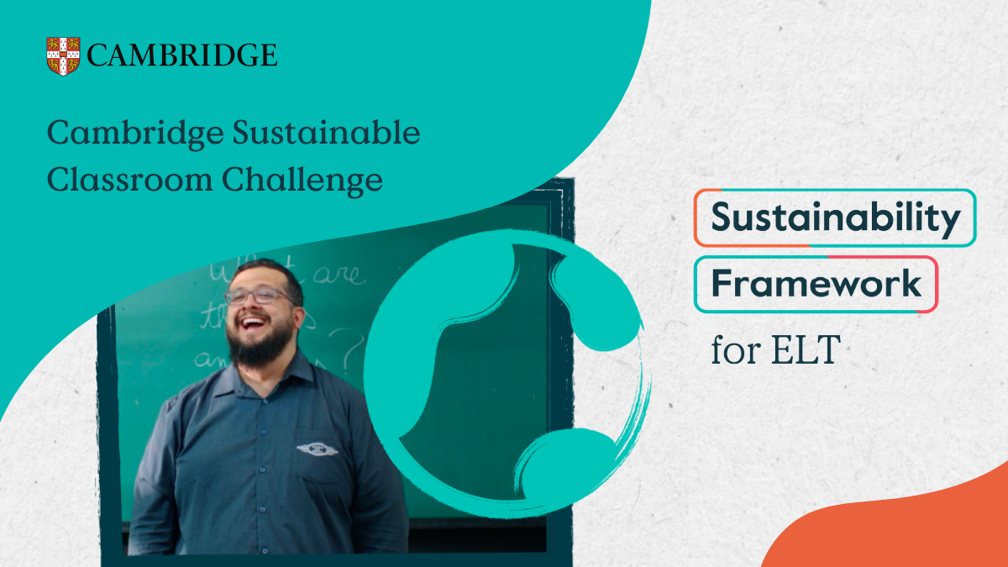
Please provide a title for your initiative.
Tell us about your learners and their learning context. You may wish to include:
- age group
- language level
- learning environment
- opportunities or challenges related to sustainability
- learner interest in sustainability topics
1. Your Learners and Context (100–150 words)

Project Title
Institution Name:
Contact Person:
Job Title:
Email Address:
Country:
Website:

Institution Information
2. Sustainability Skills Developed (100–150 words)

Response:
Response:
Which sustainability skills does your initiative develop?
Please explain how your initiative connects to the Cambridge Sustainability Framework for ELT.
You may refer to one or more of the following dimensions:
☐ Knowledge
☐ Values
☐ Innovation
☐ Transformation

3. Your Approach and Activities (300–500 words)

Describe the initiative and the activities learners took part in. Please explain:
- what learners did and how English language learning was integrated
- how sustainability skills were developed
- the role of teachers and learner

Response:
4. Impact (100–150 words)

Response:
What difference has this initiative made? You may wish to consider impact on:
- learners
- your institution
- the local community
- wider society

5. Evaluation and Evidence (200–300 words)

How have you evaluated the success of the initiative? Examples might include:
- learner feedback
- teacher observations
- surveys
- project outcomes
- assessment evidence
- community feedback

Response:
Supporting Materials
Please include any supporting evidence that helps illustrate your initiative.
Examples:
☐ Photos
☐ Learner work
☐ Videos
☐ Survey results
☐ Testimonials
☐ Other
Please describe:

Declaration

☐ I confirm that the information provided is accurate.
☐ I confirm that permission has been obtained for any materials submitted.
Name:
Date:

