YALS Conference 2022
“Teaching in Challenging Times”

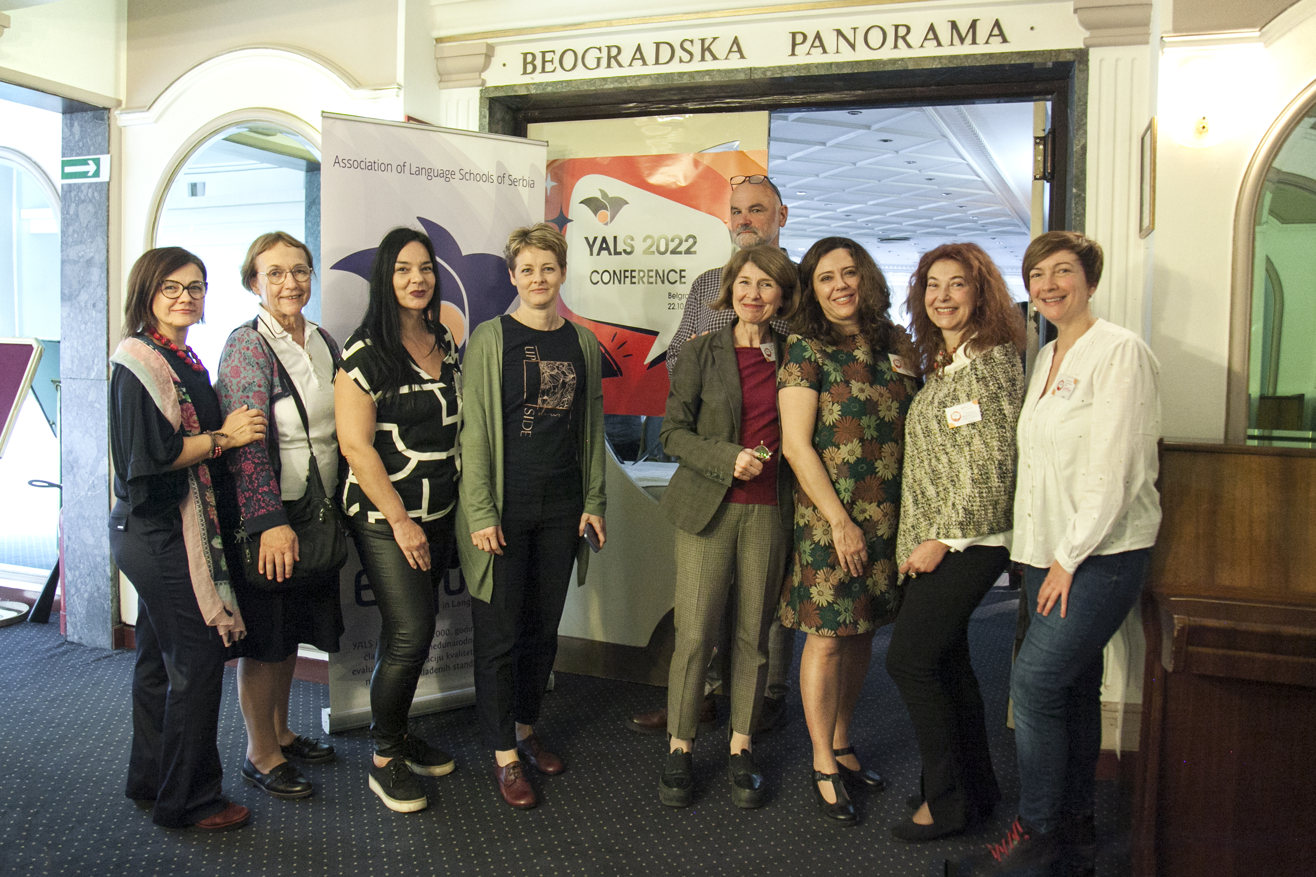
On 22nd October 2022, Yals, the Association of Language Schools of Serbia, organised a conference titled ’’TEACHING IN CHALLENGING TIMES’’ at the Palace Hotel in Belgrade. The conference, which was aimed at both private and state school teachers, was supported by Eaquals (Evaluation and Accreditation of Quality Language Services).
Marija Pejatović, Yals Chair, opened the conference, attended by 60 people. She talked about values and standards postulated by Yals and emphasised the importance of cooperating with Eaquals. The opening speech was then followed by workshops organised by Yals member teachers and two guest lecturers, Jenny Lemper from United States and Veronica Berry from UK.

The participants of the conference were able to gain more knowledge and share experiences through the topics covered below:
• Pandemic learning – perspectives from California and Serbia, Jenny Lemper, US Embassy in Serbia, Kragujevac
• NGPT (Next generation placement tool) – innovative adaptive testing in the language classroom, Ljubomir Vasojevic, Blackbird School, Cacak
• Apart but together – reflections on the 2019 YALS online spring gathering for primary school students, Marija Vojvodic and Jovana Zivkovic, Britannica Centre, Nis
• From classroom to online teaching with young learners, Andjelija Ognjanovic, Penguin English School, Jagodina
• IATEFL 2022 Belfast Conference – latest tricks of the trade for the well-being of teachers and students, Marija Pejatovic and Jelena Spasic, Oxford School, Leskovac
• Developing independent study skills in students with special learning difficulties, Veronica Berry, Livingston School, Beograd
• All work and no play kill joy on the way – how to keep students engaged in demanding exam lessons, Zeljko Ljiljak-Vukajlovic, Lingva School, Beograd

At the end of the conference all participants took part in a raffle, organised and sponsored by Blackbird School from Cacak. Other sponsors also included, The British Council, The US Embassy, Excalibur Exam Centre, Pearson, Acronolo Bookshop and Elta.
The vast majority of the attendees who filled in the evaluation form anonymously, spoke very highly of the conference with 86% of attendees giving it full rating. In fact, many remarked how well-organised it all was. They found the content to be very useful and thought the speakers were highly engaging.

Here are some comments from the evaluation form:
- Such a pleasant and well-thought-out event and overall great atmosphere. It was useful and enjoyable.
- Very useful professional event. Well done! The venue has been perfectly chosen! Keep up the good work, YALS people
- Excellent organisation, a variety of topics in the workshops, practical ideas, motivating speakers. Well done!
- Cutting edge topics – great conference!
- Great job! One of the best conferences I attended! Keep up the good work!
Quote from the event organiser:
The reason we wanted to gather here is networking. It is important to belong, especially in the challenging times, like during the Covid crisis. It was a difficult period for everyone, and yet our network worked as a safe net – we discussed, we tested, we shared and our schools survived.

